Assignment 34: TERRAFORM
Objective
To install Terraform, create and configure an AWS EC2 instance using Infrastructure as Code, add an Owner tag, apply the configuration, verify the instance in AWS, and create an SSH-enabled security group with AI assistance.

Software / Requirements
- Terraform CLI.
- AWS account with permission to create EC2 instances, security groups and related resources.
- AWS CLI or another method for configuring AWS credentials.
- PowerShell/Terminal.
- Internet connection.

Important AWS Cost & Security Note
The t2.micro instance may fall under AWS Free Tier eligibility depending on the account, region, account age and current AWS terms. AWS charges can still apply. Delete the Terraform-created resources after the practical if you do not need them. For SSH access, restricting port 22 to your own public IP (for example, YOUR_IP/32) is safer than allowing 0.0.0.0/0.

Practical 1 – Install Terraform and Verify
Download and install Terraform for your operating system. After installation, open a new PowerShell or terminal window and run:
terraform --version
Expected output will be similar to:
Terraform v1.x.x
on windows_amd64
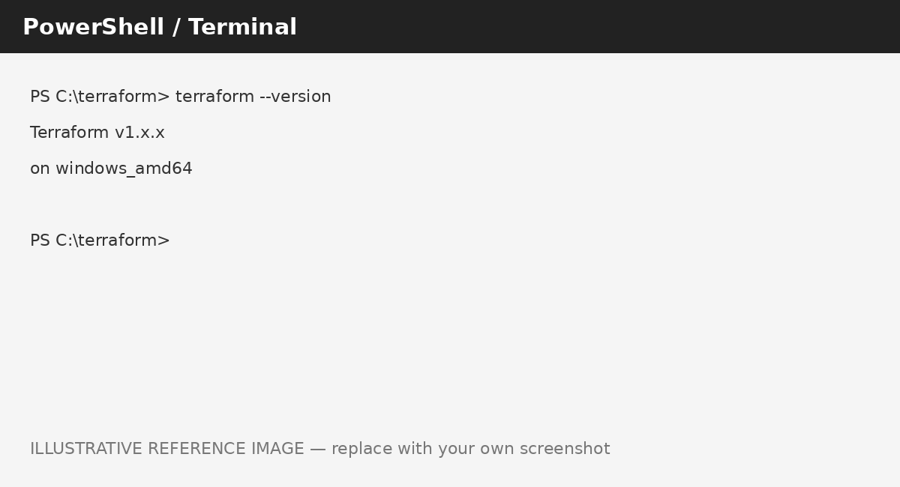
Figure 1: Illustrative Terraform version verification
Result: Terraform was installed successfully and its version was verified from the terminal.

Practical 2 – Create an AWS EC2 Instance Using Terraform
Create a working directory, for example:
mkdir terraform-ec2
cd terraform-ec2
Create a file named main.tf. A current and safer approach is to let AWS Systems Manager Parameter Store provide the latest Amazon Linux 2 AMI ID for the selected region instead of hard-coding an AMI ID that may become outdated.
terraform {
required_providers {
aws = {
source = "hashicorp/aws"
}
}
}
provider "aws" {
region = "us-east-1"
}
data "aws_ssm_parameter" "amazon_linux_2" {
name = "/aws/service/ami-amazon-linux-latest/amzn2-ami-hvm-x86_64-gp2"
}
resource "aws_instance" "terraform_ec2" {
ami = data.aws_ssm_parameter.amazon_linux_2.value
instance_type = "t2.micro"
tags = {
Name = "Terraform-EC2"
Owner = "Student Name"
}
}
Replace Student Name with your actual name. The SSM parameter lookup obtains the Amazon Linux 2 AMI appropriate for us-east-1 at apply time.
Result: The Terraform configuration defines an AWS provider in us-east-1 and an EC2 instance using the t2.micro type and Amazon Linux 2 AMI.

Practical 3 – Add the Owner Tag
The EC2 resource contains an Owner tag. Replace the placeholder with your name:
tags = {
Name = "Terraform-EC2"
Owner = "Your Name"
}
After applying the configuration, the Owner value will appear under the EC2 instance's Tags section in the AWS console.
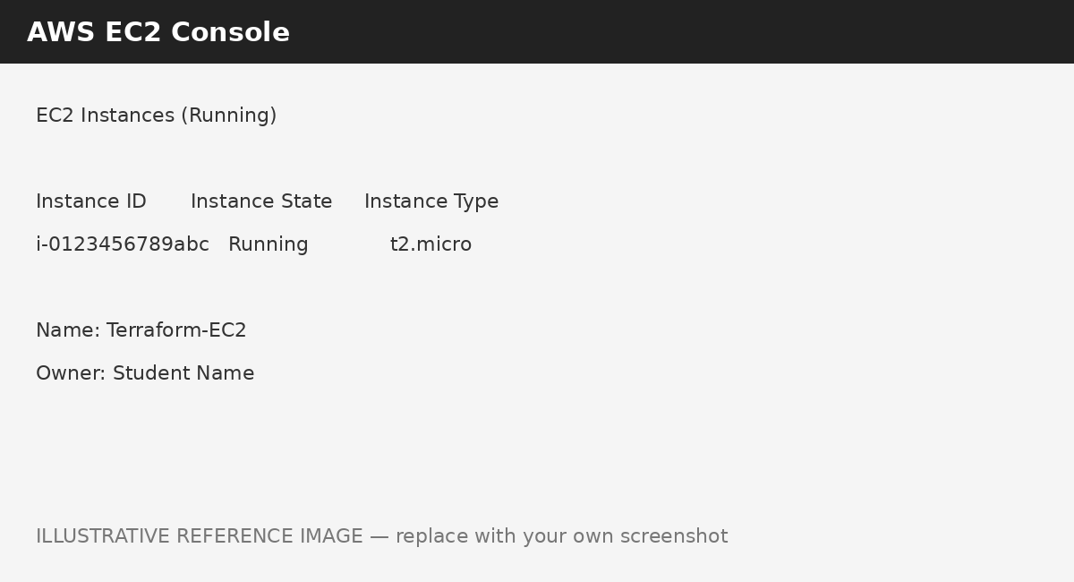
Figure 2: Illustrative AWS EC2 console showing the Owner tag
Result: The EC2 instance configuration was tagged with the Owner name for identification and management.

Practical 4 – Initialize, Apply and Verify the EC2 Instance
Before creating resources, configure AWS credentials. Then initialize the Terraform working directory:
terraform init
Review the planned changes:
terraform plan
Apply the configuration:
terraform apply
Terraform will ask for confirmation. Type:
yes
A successful result should be similar to:
Apply complete! Resources: 1 added, 0 changed, 0 destroyed.
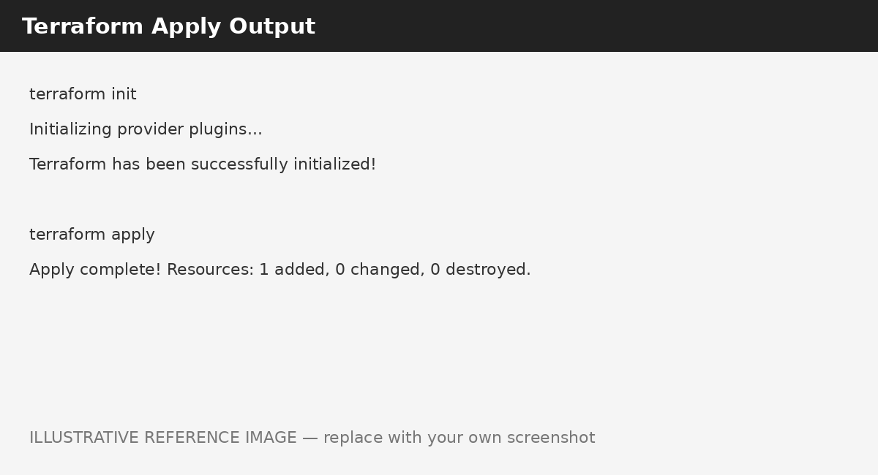
Figure 3: Illustrative Terraform init/apply output
Now open the AWS Management Console → EC2 → Instances. Confirm that the Terraform-created instance is present and its Instance State is Running. Check that the instance type is t2.micro and the Owner tag is visible.
Figure 4: Illustrative AWS EC2 running instance verification
Result: The Terraform configuration was initialized and applied successfully, creating the EC2 instance. The instance was verified in the AWS EC2 console.

Practical 5 – AI-Assisted Security Group for SSH
AI Tool Used: ChatGPT
The AI was asked to provide a minimal Terraform example that creates an AWS security group allowing inbound SSH traffic on TCP port 22 and attaches that security group to an EC2 instance. The following adapted configuration includes the security group in main.tf.
terraform {
required_providers {
aws = {
source = "hashicorp/aws"
}
}
}
provider "aws" {
region = "us-east-1"
}
data "aws_ssm_parameter" "amazon_linux_2" {
name = "/aws/service/ami-amazon-linux-latest/amzn2-ami-hvm-x86_64-gp2"
}
resource "aws_security_group" "ssh_access" {
name = "terraform-ssh-sg"
description = "Allow SSH access to the Terraform EC2 instance"
ingress {
description = "SSH from administrator IP"
from_port = 22
to_port = 22
protocol = "tcp"
cidr_blocks = ["YOUR_PUBLIC_IP/32"]
}
egress {
from_port = 0
to_port = 0
protocol = "-1"
cidr_blocks = ["0.0.0.0/0"]
}
tags = {
Name = "Terraform-SSH-SG"
Owner = "Your Name"
}
}
resource "aws_instance" "terraform_ec2" {
ami = data.aws_ssm_parameter.amazon_linux_2.value
instance_type = "t2.micro"
vpc_security_group_ids = [aws_security_group.ssh_access.id]
tags = {
Name = "Terraform-EC2"
Owner = "Your Name"
}
}
Replace YOUR_PUBLIC_IP with your public IPv4 address followed by /32. If your instructor specifically requires unrestricted SSH for demonstration, 0.0.0.0/0 can be used, but it exposes port 22 to the Internet and is not recommended for real deployments.
Run:
terraform fmt
terraform validate
terraform plan
terraform apply
After applying, open AWS Console → EC2 → Security Groups. Select terraform-ssh-sg and verify that the inbound rule allows TCP port 22 from the configured source.
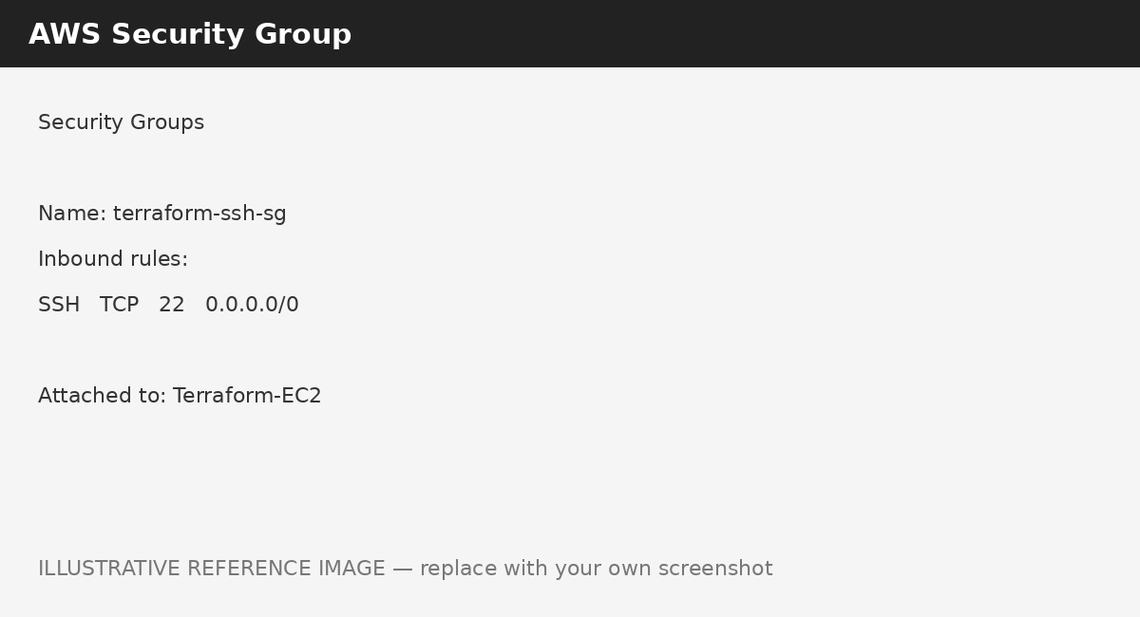
Figure 5: Illustrative AWS Security Group showing SSH port 22
Result: An SSH-enabled security group was created using Terraform and attached to the EC2 instance. The security group can be verified in the AWS console.

AI Errors / Improvements Observed
The initial AI-style minimal example can use a fixed AMI ID or 0.0.0.0/0 for SSH. A fixed AMI ID can become outdated, while unrestricted SSH is a security risk. The improved configuration dynamically retrieves the Amazon Linux 2 AMI through AWS Systems Manager Parameter Store and restricts SSH to a specific public IP using /32. The configuration also uses terraform fmt and terraform validate before apply.

Terraform Workflow
main.tf
↓
terraform init
↓
terraform fmt / validate
↓
terraform plan
↓
terraform apply
↓
AWS EC2 + Security Group
↓
Verify in AWS Console

Screenshot Checklist
- 1. Terraform --version output.
- 2. Terraform configuration / main.tf.
- 3. Terraform init and apply output.
- 4. AWS EC2 instance showing Running state.
- 5. AWS EC2 Tags showing Owner.
- 6. AWS Security Group showing inbound SSH port 22.
Photo note: The images in this document are illustrative reference photos, not proof of an actual AWS/Terraform run. Replace them with your own screenshots from your terminal and AWS console for final submission.

Cleanup – Avoid Unnecessary AWS Charges
When the practical is complete and you no longer need the resources, run the following from the same Terraform directory:
terraform destroy
Review the resources that will be removed and type yes when prompted.

Conclusion
Terraform was installed and verified successfully. A Terraform configuration was created to provision an Amazon Linux 2 t2.micro EC2 instance in us-east-1 and identify it using an Owner tag. The configuration was initialized and applied, and the resulting instance was verified in the AWS console. Finally, an AI-assisted security group was added to allow SSH access, with security improvements such as restricting SSH to the administrator's public IP.

